# Step-By-Step Guide To Setup a4data automation project on your system.

## Pre requisites

Install all the below

1. You need to signup github account and share the user details to Admin (First time users)
2. Java 1.8
3. IntelliJ IDEA 2019.1.2 (Community Edition) use the latest version.
4. Tortoise GIT
5. Gradle - use the latest version.

## **How to clone the git repository to your local machine**

1. Go to command prompt
2. Create a directory with mentioned name or any name of your choice.
3. Go to that directory with cd command like shown. (highlighted yellow)

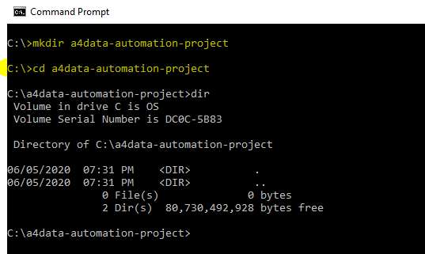

## **Install Tortoise GIT**

1. You need to install Tortoise GIT from this url - <https://tortoisegit.org/download/> (windows or Mac based on your system configuration.)
2. After installation type git on command prompt to see the below

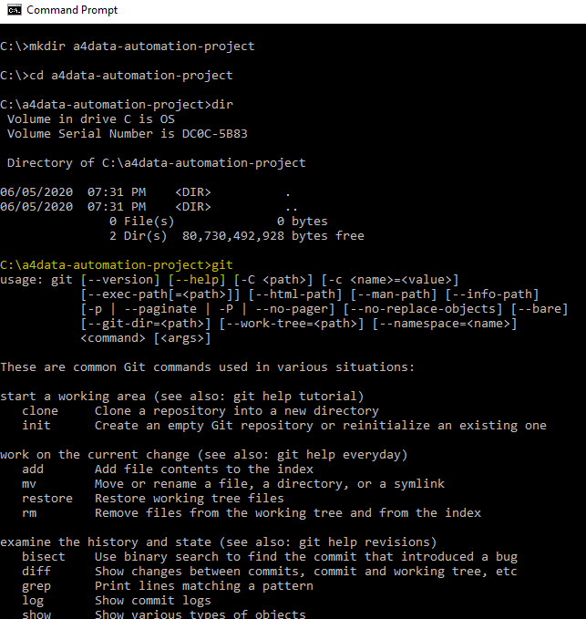

## **GIT Repository**

**Go to URL** <https://github.com/haigopi/functional-automation> to see the git repository.

**You will see the below screenshot once you hit the URL.**

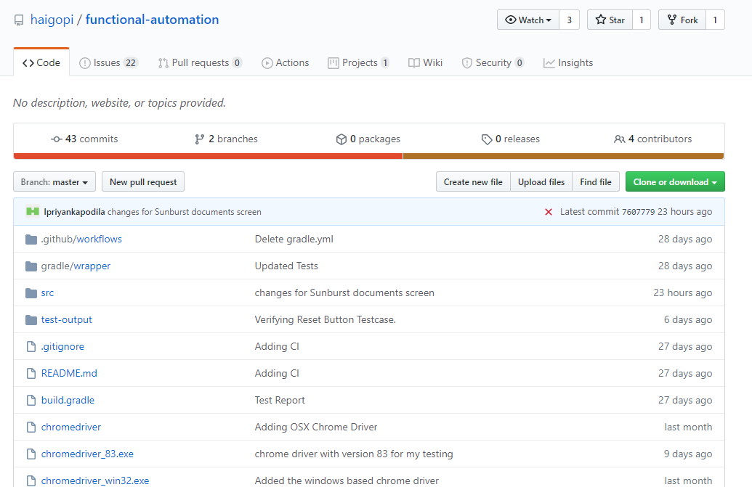

## **Clone URL from the highlighted yellow. Like shown below.**

<https://github.com/haigopi/functional-automation.git> -> clone url just incase if you can’t find.

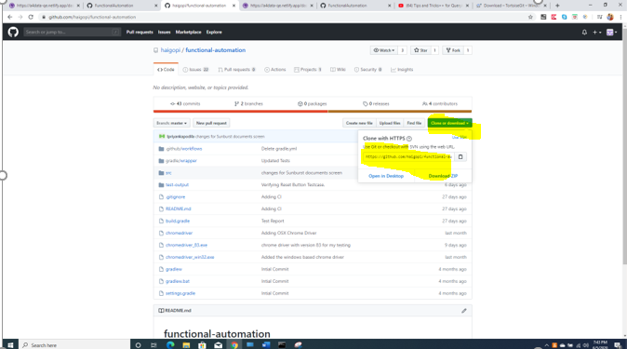

## **How to clone**

Do git clone as shown below

git clone <https://github.com/haigopi/functional-automation.git> --- use this command on the command prompt to see that code is downloaded to your local.

NOTE - First time users -> Please enter your git hub user credentials which you used. On the pop up.

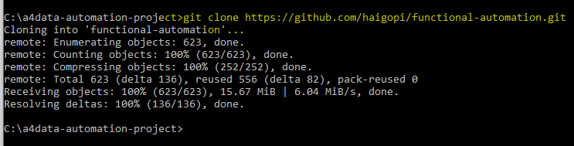

This is what you see below from windows explorer once successfully done with above step.

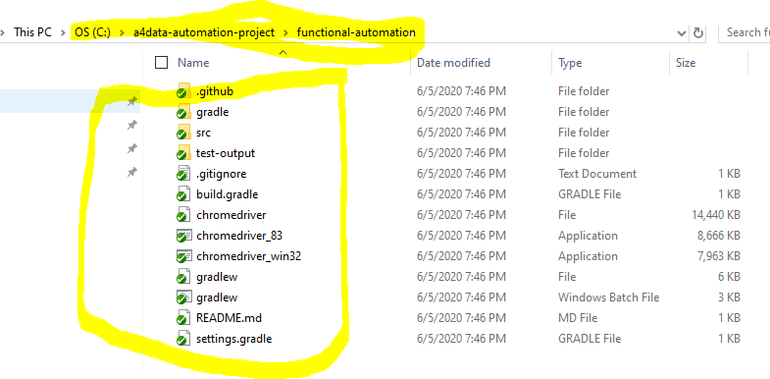

## How to open the functional-automation project on IntelliJ

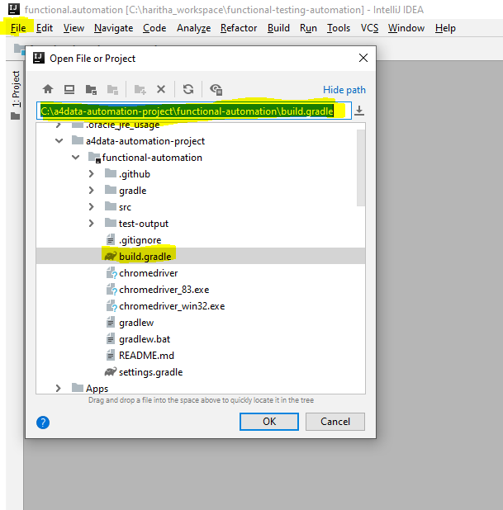

Click OK

After OK you see the below and select the Open as Project

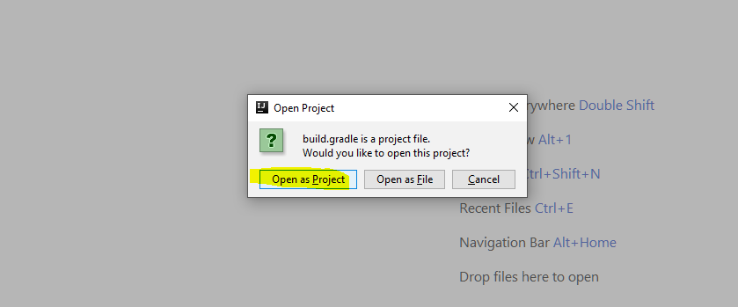

It will ask for the Gradle setup after the above step.

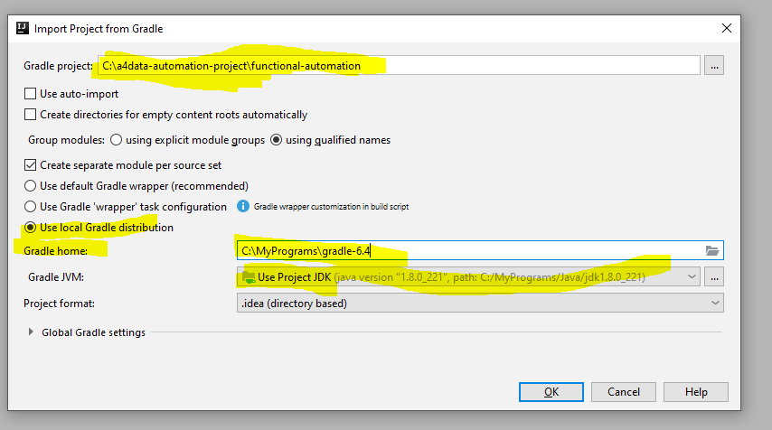

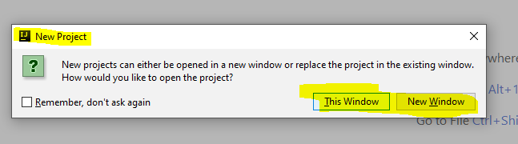

Click New Window to see the below.

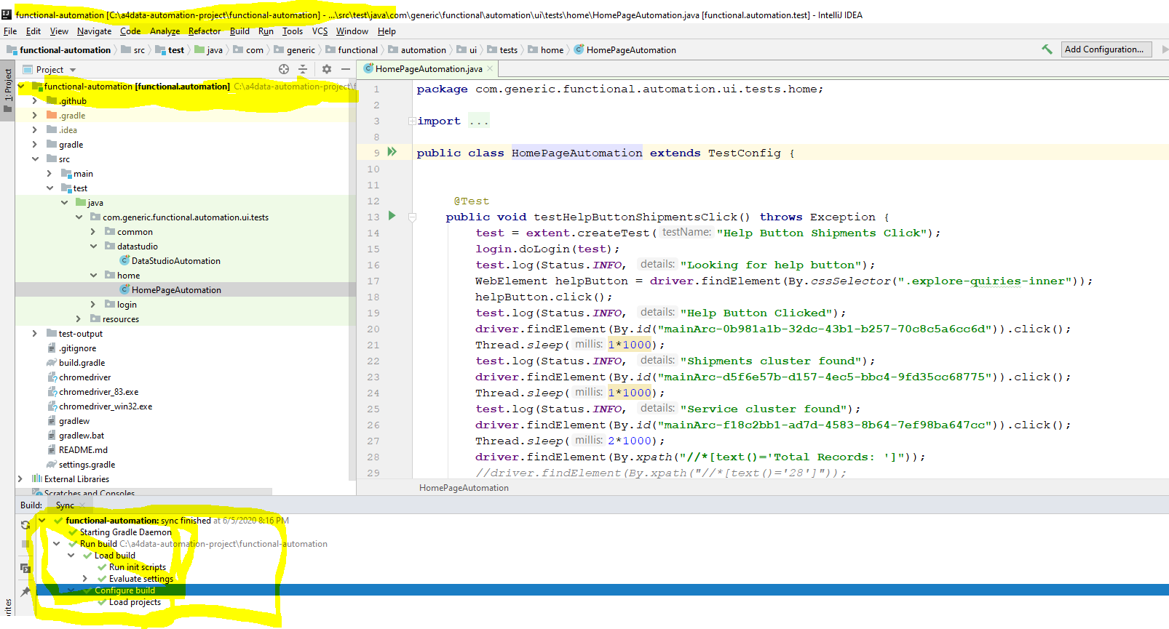

## All the chrome drivers are already available with the Project Repository.

Chromedriver for Macbook

Chromedriver for the Win 32 (compatible with chrome browser version 83.x and 81.x)

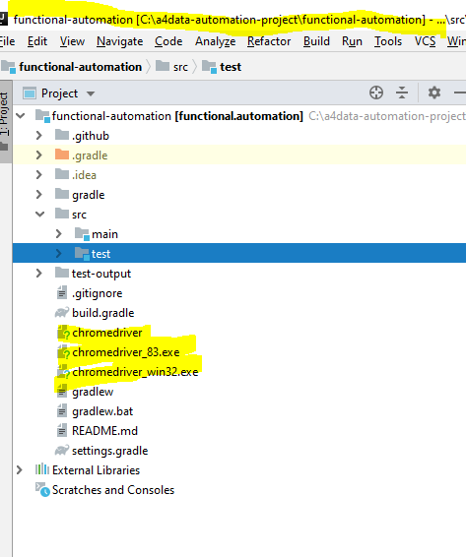

## Ready to use this for your development.

Happy coding the automation project 😊